HugBag Instruction Manual

# Objective:

HugBag’s intention is to make use of the child’s strong and gross motor based actions, while exploring continuous and co-located coupling of action and effect tightly connected to the child’s gross motor activity. There are two versions of HugBag: “Standard” and “Fluffy”.

# Components:

## Hardware:

* 70cm diameter GYM ball
* Plastic pot base
* White, semi-transparent fabric cover
* USB Speakers
* USB Hub
* MS Kinect sensor
* Arduino computer
* 3-axis accelerometer (only standard version)
* Ikea RGB flexible ledstrip (only standard version)
* Two Addressable RGB ledstrips with 150Leds each (only fluffy version)
* Corrugated cellophane cover (only fluffy version)

## Software:

* Computer running MS Windows 7
* MS Kinect SDK
* Ableton Live 9.0 Suite (with Max4Live)
* Virtual MIDI cable (LoopMIDI)
* A MIDI-serial bridge (Hairless MIDI)

# Construction:

The construct is made of a semi-inflated ball resting on a semi-circular plate base. An accelerometer mounted on the base detects the tilt direction and angle (only Standard HugBag) while a Microsoft® Kinect sensor, also mounted on the base, detects the location and degree of deformation while being hugged, pushed or punched. These sensors control evolving light patterns (via Ledstrips) and sounds (via integrated usb speakers) as a response to interaction (Figure 6). Fluffy HugBag is covered in a corrugated structure of cellophane paper, which provides richer tactile and audible responses to touch. It has addressable lights, arranged in a spiral pattern around the whole semi-inflated ball construction, and in contrast to Standard HugBag, only the touched area lights up.

Two Max4Live device have been created, **MultiCamMidiController** and **MoodController.**

**MultiCamMidiController** obtains the image from the Kinect or webcam (Windows only), processes the image and outputs control parameters to be mapped to other Ableton Live devices. It also output the control parameters to MIDI controls changes, so you can use them to communicate with the Arduino using a Virtual MIDI cable and a MIDI-serial bridge.

**MoodController** can control HugBag’s mood and change the sound and light response using the same control parameters from the detection. It mixes different soundtracks as a response to the same interaction. MoodController also outputs MIDI messages to arduino.

The Ledstrips and the accelerometer are connected to the arduino computer, which controls the light patters as a response to the accelerometer’s data and the control parameters from sent via MIDI messages from Ableton Live.

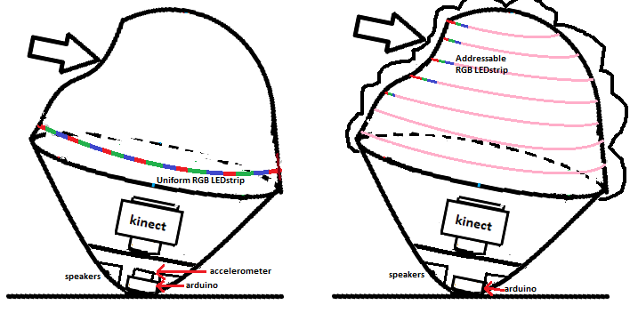

Figure 1. Left: Standard HugBag with Uniform RGB LEDstrip and accelerometer. Right: Fluffy HugBag with corrugated material and addressable Ledstrip that only lights in the area being dented.

# Operation

## Hug detection:

First, the Kinect sensor detects the HugBag’s inner surface when there is no interaction and stores the image as a “baseline”. Any camera of the Kinect can be used (depth, color, infrared), but for best results, the infrared camera is recommended, as it is insensitive to environment lightning and has a wider range compared to the depth sensor.

When the hugbag is being dented, the Kinect sensor detects the area being deformated (Figure 2.a) , smoothens the image to remove noise, and substracts the baseline to only process the change of the surface (Figure 2.b). If the change in the surface is “big enough”, then a blob is created in that area (Figure 2.c). Blobs are 2-dimensional elliptical shapes with a center (Cx,Cy) and an size (CA). Each blob’s coordinates are transformed to polar coordinates using the distance from the center of the coordinate system (Cr), angle from the coordinate system (Cθ) and area of the blob (CA). All detected blobs are averaged into a single blob with center and size information (r, θ, A).

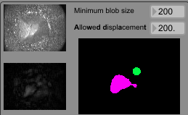

Deformated area

Deformation after baseline removal

Detected blobs

a)

b)

c)

Figure 2. a) Image as captured from the infra-red camera, b) processed image after smoothing and baseline removal, c) detected blobs

## Sound and Light

The blob information is used to output sound and light out of the hugbag. Each control parameter (r, θ, A) is used to control specific sound or light effect as shown in Table 1.

Soundtracks are described in terms of dynamism (“active”, “passive”) and timbre (“raw”, “fine”), and grouped into the location where they are produced in Hugbag (“top” or “sides”) (Figure 3). Light effects are described in terms of color (hue, saturation, value). Standard Hugbag is light up uniformly, while Fluffy HugBag is light up only where the interaction happens.

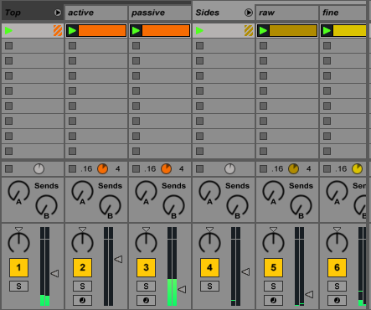

Figure 3. Soundtracks grouped into two groups (Top and Sides). Interaction with the top of HugBag will allow more volume to active and passive soundtracks, while interaction with sides of HugBag will allow more volume to raw and fine soundtracks, depending on the HugBag’s mood.

The distance from the center (r) controls the track volume mixer, meaning that blobs detected further away from the center of HugBag will produce tracks associated with the “Sides” group to have higher volume while tracks in the “Top” group will have lower volume. While blobs detected closer to the center will mix the soundtracks the opposite way. For Standard HugBag, the r controls the color saturation, therefore blobs closer to the top will be whiter than blobs closer to the sides. For Fluffy HugBag, r is part of the location where the light effect will happen.

The angle of the blobs with respect to the HugBags center (θ) will modify the sound properties of each specific track, this could be the pitch, tone, oscillation frequency, etc… depending on the soundtrack. For standard HugBag, θ controls color Hue. For Fluffy HugBag, θ is part of the location where the light effect will happen.

The size of the blobs will control the Master volume for all soundtracks. For Standard HugBag, A controls the brightness or value of the color. For Fluffy HugBag, A controls the sparse of leds that will light up around the area where the interaction is happening. The bigger the blob, the more LEDs will light up. It also controls the value of the color.

|  |  |  |  |
| --- | --- | --- | --- |
| Control | Sound | Light (Standard) | Light (Fluffy) |
| r | Group mixing | Color saturation | Location center |
| θ (th) | Sound quality | Color hue | Location center |
| A | Volume | Color value | Location sparse,  color brightness |
| Mood wheel | Mood (track mixing) | --- | Color (red,green,blue) |

Table 1. Control parameters mapping to sound and light effects

## Controlling HugBags mood:

Using exactly the same control parameters (r, θ, A), the sound and light effects can be changed. This can be used to adapt to each specific child or situation. The gray dot can be moved around the mood wheel to control how the volume mixer of tracks can be adjusted (Figure 4). If positioned closer to the left area, the passive sounds will sound louder, while the top area will make finer sounds sound louder, etc. For the Standard HugBag, the mood wheel does not affect the lightning. For the Fluffy HugBag, the mood wheel changes the color’s hue and saturation of the area being dented.

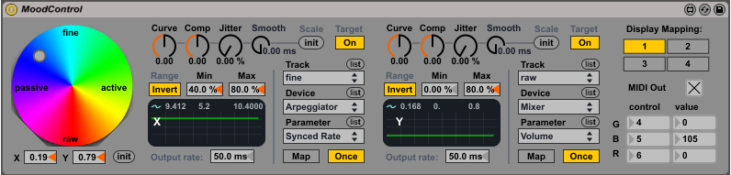

Figure 4. MoodControl max4live device. Moving the gray dot over the color-wheel will change the volume mixing of each soundtrack gradually.

## Mapping of parameters to Live devices

Important: It is not recommended to change these settings unless you know very well what you are doing!

Both Max4Live devices allow their control parameters to be mapped to up to four different Ableton Live knobs of different devices. You can select which of the four mappings with the “Display Mapping” on the top right corner of the device (Figure 4). The range of the signal can be adjusted by its minimum and maximum values, and it can also be inverted (0% becomes 100% and viceversa). The output signal of each parameter can be modified by changing the curve, compressor, jitter and smoothness of the signal.

* Curve: Negative values produce an exponential curve, positive values produce a logarithmic curve.
* Compressor: Positive values force parameter to the outer extremes, negative values toward the middle range.
* Jitter: adds random variation to the current value
* Smooth: Smooth value changes

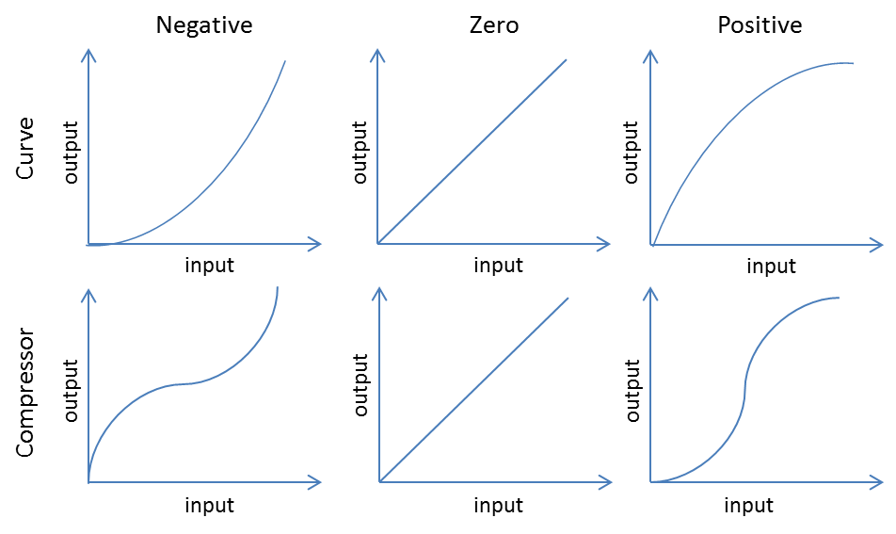

Figure 5. Curve and Compressor behavior for negative, zero and positive values.

## Midi messages to Arduino

Important: It is not recommended to change these settings unless you know very well what you are doing!

Both Max4Live devices allow their control parameters to be mapped to one MIDI control change. Ableton talks to the loopMIDI port. (Figure 5.a) Then LoopMIDI communicates to arduino via serial port using the Hairless MIDI program (Figure 5.b). The arduino board is configured to receive the MIDI control changes shown in Table 2.

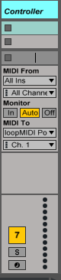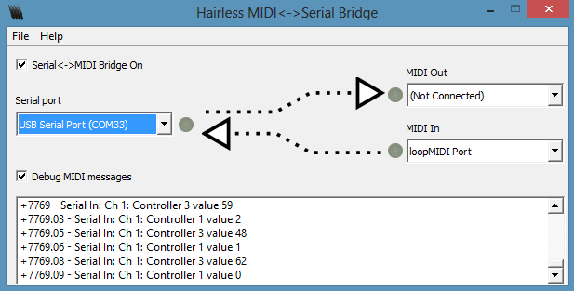

Figure 6. MIDI communication setup. Ableton Live controller track outputs MIDI data to the loopMIDI port (left). Then Hairless MIDI takes the messages from the loopMIDI port and outputs them via serial port to the arduino computer (right). In this image “USB Serial Port Com33”. But it can be different for each computer.

|  |  |  |
| --- | --- | --- |
| MIDI Control Change | Control Parameter (standard) | Control Parameter (Fluffy) |
| Ctrl. 1 | R | X |
| Ctrl. 2 | θ | Y |
| Ctrl. 3 | A | A |
| Ctrl. 4 | - | Green (mood) |
| Ctrl. 5 | - | Blue (mood) |
| Ctrl. 6 | - | Red (mood) |

Table 2. Control parameter to MIDI control changes mapping for each type of HugBag

HugBag Quick Start Guide

When you click on the HugBag desktop shortcut, two programs will open, Hariless MIDI and Ableton Live 9. For normal operation, follow the following steps. Each step is illustrated with a red number in Figure 6. In Live, the Mood controller is at the right of the MultiCamMidiController, not at the bottom.

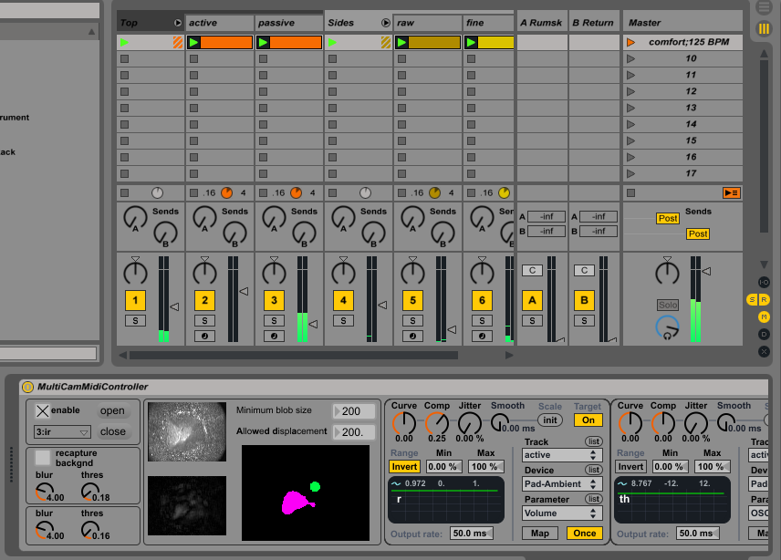

**1**

**2**

**3**

**4**

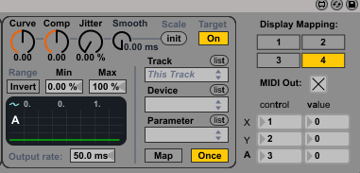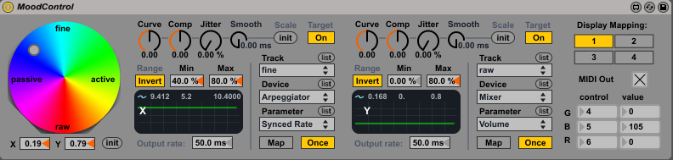

**5**

**6**

**7**

Figure 7. Screenshot of the Ableton Live Window. Normal Operation steps are depicted with red numbers. In Live, the Mood controller is at the right of the MultiCamMidiController, not below.

1. Check that the infra-red camera is selected (3:ir) and click open
2. Click recapture background
3. Check that the inner surface image is constant and showing the inner surface of HugBag, and that both the post-processing and blob-detection image are black.
4. Press spacebar to start the soundtracks, check that there are green bars of sound are shown in the tracks
5. Check that the MIDI Out checkbox for the blob control parameters is checked and that the correct MIDI control numbers are displayed correctly
6. Modify the initial mood of the HugBag using the gray dot over the MoodWheel
7. Check that the MIDI Out checkbox for the mood control parameters is checked and the correct MIDI control numbers are displayed correctly
8. Start interacting with HugBag

# TroubleShooting:

## Sound is fine, but no lights are visible when interacting with HugBag

If there is no lights output, it can be due to faulty power supply, or faulty communication with arduino.

1. Check that the 12 V power supply for the LEDstrip is connected to the mains and connected to the LEDstrip.
2. Check that the communication between Arduino and the computer are correct by checking the following settings in Hairless MIDI.

Hairless MIDI handles the communication between Ableton Live and Arduino, which controls the lightning of HugBag (Figure 6).

The first thing to check is that when Hairless MIDI opens:

* “Serial <->MIDI Bridge On” is checked
* Serial Port has either “USB Serial Port (COMXX)” selected, or “Arduino Leonardo (COMXX)” Selected.
* MIDI In has “loopMIDI Port” selected.

If those three parameters are correct, most likely the communication with the Arduino board will have no problems.

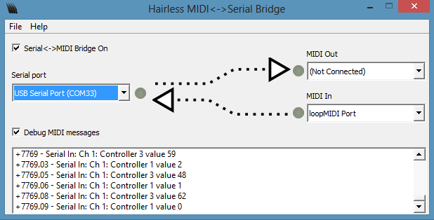

Figure 8. Hariless MIDI program window. Check that settings look like this figure.

If those parameters were fine, but interacting with HugBag does not cause light output, then check that the gray dots next to “USB Serial Port” and “MIDI In” light up in green while interacting with HugBag. If there is no change in the gray dots while interacting with HugBag, then there is no communication, try unchecking the “Serial <->MIDI Bridge On” checkbox, disconnecting and reconnecting the USB cable marked as speakers and checking the “Serial <->MIDI Bridge On” box again.

If the gray dots light up, then communication is happening, but maybe the messages are not formatted correctly. Turn on the checkbox “Debug MIDI messages” and check that “Serial In: Ch 1: Controler X value Y” messages appear while interacting. If a different message appears, then try unchecking the “Serial <->MIDI Bridge On” checkbox, disconnecting and reconnecting the USB cable marked as speakers and checking the “Serial <->MIDI Bridge On” box again.

## Sound coming from the computer instead of the HugBag

Most probably, the audio configuration in Ableton Live 9.0 got desconfigured.

1. Click on Options->Preferences
2. In the preferences window, click on the “Audio” tab
3. In the Audio output device select the “Speakers (USB audio XX) DX” option. This text vary from computer to computer, but just select the one with USB and DX and it will be OK.
4. Close the preference window, now the audio should come from the HugBag.

## The sound flickers and is not constant when keeping HugBag dented

This can happen if communication between the Kinect sensor and Ableton Live is not well synchronized. You can observe that the inner surface image disappears and reappears. This can happen with the infra-red (ir) camera for some reason, it does not happen with the depth or rgb cameras. Anyway, if this happens, just follow the button sequence as depicted in Figure 8. First “close” the Kinect communication (1), change the “3:ir” camera to “1:depth” (2), open the communication (3), close the communication again (1), change the Kinect camera to “3:ir” again (2) and open communication again (3).

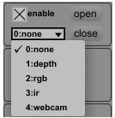

2

1

3

Figure 9. Kinect communication buttons to close (1), open (3), or change (2) the Kinect camera.

## HugBag suddenly starts sounding by itself

Maybe it is deflating a little bit, or the lightning conditions have changed.

In any case, just click on the “recapture backgnd” checkbox of the MultiCamMidiController device (Figure 7). If after recapturing background, the problem persist, then adjust threshold as explained in the next section.

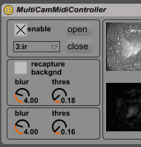

Figure 10. Location of the recapture backgnd function to reduce HugBag random activation.

## HugBag is not sensitive enough or is very sensitive

This might be a thresholding problem. There are two types of thresholds in the MulitCamMidiController device: Pre-processing and Post-processing.



1

2

Figure 11. Pre-processing (1) and post-processing (2) blurring and thresholding parameters

The first one (pre-processing) is the most important, it happens before background removal and is mainly used to reduce noise and adjust HugBags sensitivity. The post-processing one happens just before blob detection and is used mainly to get rid of small non-collocated blobs by post-blurring the image and adding another post-blur small threshold

If HugBag is not sensitive enough, decrease the pre-processing threshold, if is too sensitive, increase the pre-processing threshold.

If HugBag sensitivity is fine, but blobs appear in other places apart from where the interaction is happening, increase the post-processing threshold. Increasing this threshold too much will also reduce sensitivity, so be careful.

The recommended ranges for both thresholds for the 3:ir camera are:

|  |  |  |
| --- | --- | --- |
|  | Min value | Max value |
| Pre-processing blur | 3.0 | 10.0 |
| Pre-processing threshold | 0.15 | 0.25 |
| Post-processing blur | 1.0 | 5.0 |
| Post-processing threshold | 0.10 | 0.20 |

Table 3. Min and Max recommended values for blur and threshold pre-processing and post-processing parameters